Rat Dissection Validation (25 marks) Name: _______________________

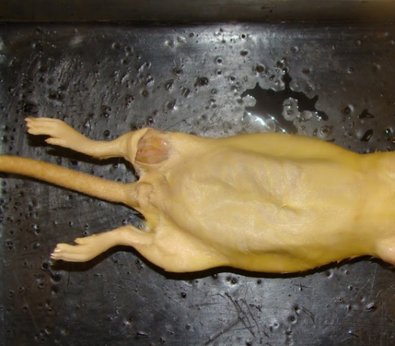
- Is this rat a male or female? _______________________________
- How do you know? _______________________________________

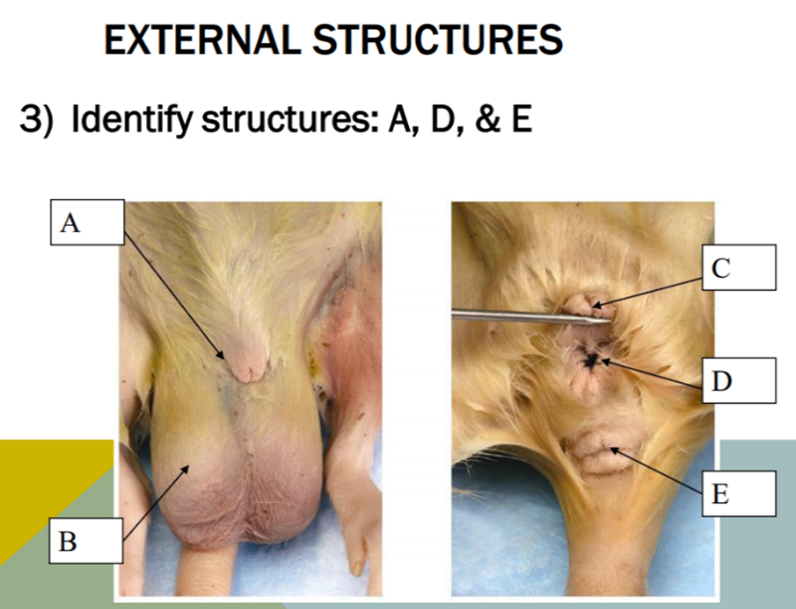

- Label the above structures (1 mark each)
- __________________________
- __________________________
- __________________________
- __________________________
- __________________________

Describe 5 differences between the reproductive systems/organs or process between rats and humans:
______________________________________________________________________________________________
_________________________________________________________________________________________________________________________________________________________________________________________________________________________________________________________________________________________________________________________________________________________________________________________________________________________________________________________________________________________________________________________________________________________________________________________________________________________________________________________________________________________
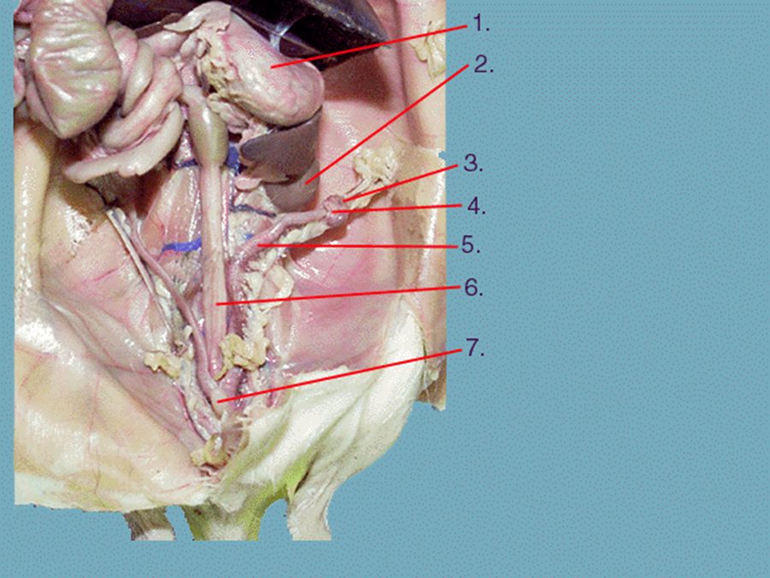
- Label the following in a female (1 mark each)
Ovary, Bladder, Stomach, Kidney, Fallopian Tube, Uterine horn

- ____________________
- _____________________
- _____________________
- _____________________
- _____________________

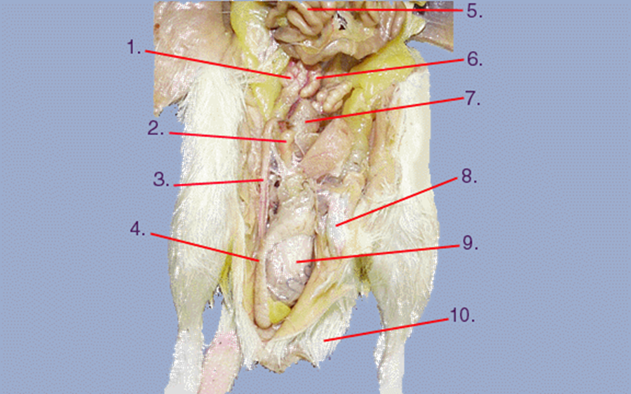
- Label the following in a male (1 mark each)
Seminal vesicle, testis, epididymis, small intestine, prostate gland, penis, scrotum, vas deferens, scrotum

- ____________________
- _____________________
- _____________________
- _____________________
- _____________________
- _____________________
- _____________________
- _____________________

